Game Project Documentation

**This is output of game program:**

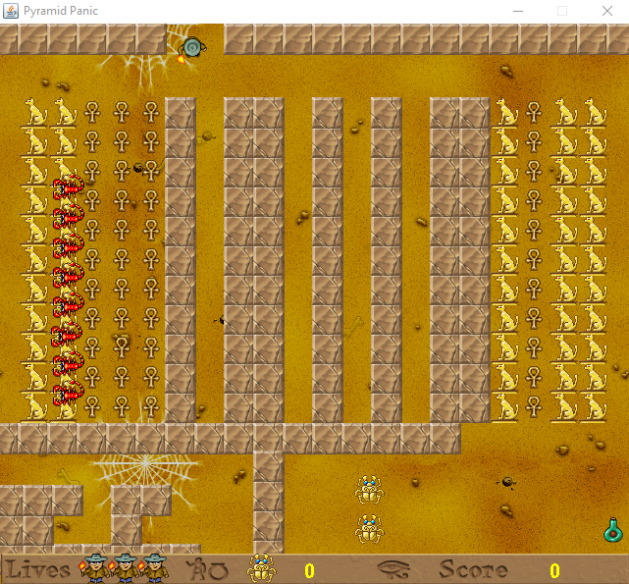

You play an explorer who has become trapped while investigating a large

pyramid complex. All around lie the treasures of an ancient pharaoh, but pyramids are hazardous places and danger lurks around every corner. Deadly scorpions and beetles will block your progress and mummies will hunt you down. Only by keeping your wits about you can you hope to unravel the secrets of the great pyramid and escape as a rich man.

You control the explorer using the arrow keys. Many obstacles will block your path, keeping you from taking the treasures and eventually escaping to freedom. Beetles will only move vertically while scorpions only move horizontally. Mummies move in all directions. These enemies are clever and will react when they see you by trying to catch you and end your explorations. Some wall segments can be pushed, allowing you to reach other areas or hide from enemies. The pyramid also contains scarabs that you can use to make the mummies temporarily vulnerable— allowing you to hunt them for extra points.

Deep within the center of the pyramid lies its greatest treasure, the fabled sword of the sun god Ra. It is this great treasure that casts the unnatural light which reaches throughout the pyramid and allows you to see your way so clearly. It is precious beyond measure, but in taking it you will upset that delicate system and the pyramid will be plunged into eerie darkness.

Only the small glow remaining in the sword will light your way now, and formerly simple puzzles will seem new and challenging. All is not lost, however, for the sword has a second function. When wielding the sword you will be able to press and hold the spacebar to temporarily reactivate its glow. The sword transmutes gold into pure light, lighting your way but reducing your score. When the sword is active, the mummies will flee as they do when a scarab is active, making your journey easier, but draining your wealth.

**Code’s introduction and Overview**

In the github repository, I provided nineteen java files which were saved in the

pyramidPanic folder. PyramidPanicGame.java, which was one of java file that was saved in the pyramidPanic folder, provided main function to compile the program for this game. There were many png files and wav files which were saved in the pyramidPanic/Pictures folder. These png files and wav files are used in the PyramidPanicGame code. There were other two java files, which were called KeyboardControl.java and KeyboardEvents.java, were both saved in the pyramidPanic/GameKeyControl folder. The implementation of this game project was to upload png files, upload wav files, place images on the game map, play music and allow user to control explorer from keyboard when the game is begun.

**Game Map**

The map is composed of a image file (Background2.png), onto which various obstructions are placed.

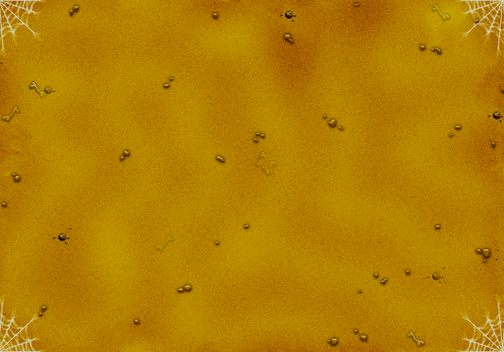

The two obstructions that are placed on the map are (Wall1.png),

IMG_256

and (Wall2.png).

IMG_256

The two different wall segments that are placed on the map are a horizontal block

(Block\_hor.png)

IMG_256

and a vertical block (Block\_vert.png)

IMG_256

These two wall segments can be pushed by the explorer. A sound (Block.wav) is played when the wall segment is pushed.

The two different treasures that are placed on the map are (Treasure1.png)

IMG_256

and (Treasure2.png)

IMG_256

The explorer’s score will be increased to ten from zero when he pick up one treasure. A sound (Treasure.wav)is played when one treasure is picked up.

There are many scarabs (Scarab.png) that are placed on the map.

IMG_256

The scarab’s number will be increased to one from zero when explorer picks up one scarab. The explorer’s scores can be increased to ten when he uses scarabs to drive one mummy away.

IMG_256 (Lives.png) is explorer’s lives numbers. There are three lives numbers on the game screen. It means explorer has three lives opportunities.

There are two potions (Potion.png)that are placed on the map

IMG_256

The explorer will have one more lives number when he picks up one potion.

There is one sword (Sword.png)that is placed on the map

IMG_256

After explorer picks up sword, the pyramid’s light will become dark.But explorer’s scores will be decreased when he uses sword to drive one mummy away.

This is explorer IMG_256(Explorer\_down\_strip4.png) IMG_256(Explorer\_left\_strip4.png) IMG_256 (Explorer\_right\_strip4.png) IMG_256(Explorer\_up\_strip4.png) who walks in all directions

This is beetle IMG_256(Beetle\_down\_strip4.png) IMG_256(Beetle\_up\_dtrip4.png) who moves vertically. A sound (Beetle.wav) is played when explorer is closer to beetles.

This is mummy IMG_256(Mummy\_down\_strip4.png) IMG_256(Mummy\_left\_strip4.png) IMG_256(Mummy\_right\_strip4.png) IMG_256(Mummy\_up\_strip4.png) who moves in all directions.

This is scorpion IMG_256(Scorpion\_left\_strip4.png) IMG_256(Scorpion\_right\_strip4.png) who moves horizontally. A sound (Scorpion.wav) is played when explorer is closer to scorpions.

The music (Music.mid)is played when the game is begun. A sound (Die.wav)is played when explorer is killed. The music (Game over.wav) is played when the game is finished.